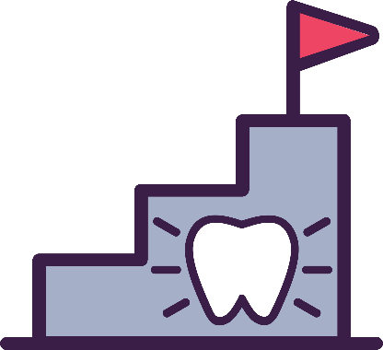
Dental Steps

Dental Steps for ME:
Independent Practice Dental Hygienist Job Description

Job Summary:
Work in primary care setting where the dental hygienist is a member of the health team treating oral health as part of overall health. Connected virtually to a dental clinic, the Independent Practice Dental Hygienist (IPDH) maintains all preventive and early intervention services for patients of the primary care site, ages 0-5, who do not have a dental home. The IPDH provides on-site patient and medical team support and collaborates virtually with a participating dentist to provide diagnostic, preventive, and early intervention treatment in the medical home and support referral and follow-up activities as needed.

Key responsibilities:
- Develop relationships with medical providers.
- Collaborate with medical and dental staff to provide access to comprehensive oral healthcare for the age 0-5 patient population.
- Participate in initial and on-going training to provide high level care and interdisciplinary collaboration in the medical setting.
- Collect electronic dental records including digital radiographs, photographs and charting of dental findings.
- Record patient record using both electronic health and dental records.
- Communicate with dentist via technology to support dentist’s teledentistry examination of the patient case, record findings in the patient’s electronic health/dental records, and follow-up with care coordination as needed.
- Carry out all aspects of the patient care plan that can be performed by an IPDH in the medical setting including:
  - Health promotion and prevention education for patients, parents, and caregivers
  - Oral health risk assessments
  - Preventive procedures such as application of fluoride varnish, dental prophylaxis, and silver diamine fluoride (SDF)
  - Provide early intervention caries arrest services including placement of SDF and temporary fillings using glass ionomer.
- Coordinate with medical site and dental office staff to ensure complete care management and continuity of care.
- Maintain portable equipment and perform necessary maintenance.
- Comply with all pertinent regulation that govern the practice of dental hygiene including but not limited to state statues, rules, and regulations, and those set forth by OSHA and HIPAA.
- Uphold infection control standards at all times complying with current CDC recommendations.
- Work with site staff and patients to coordinate schedule.
- Support medical team integration of oral health care into well-child visits.
- Attend and participate in staff meetings and other staff events.
- Participate in quality improvement activities.
- Provide leadership as a dental professional in a community setting

Requirements:
- Must hold a current Registered Dental Hygienist (RDH) license with Independent Practice (IPDH) authority.
- Must have experience using electronic health records.
- Must be proficient in the use of technology.
- Must demonstrate effective communication and problem-solving skills
- Prefer 5+ years of experience in community settings with priority given to those with pediatric and medical dental integration experience.
- Ability to work in a fast-paced environment and maintain professional composure and demeanor
- Ability to manage multiple priorities and projects simultaneously
- Knowledge about Medicaid dental reimbursement preferred
- Ability to work independently and self-directed

Physical Requirements:
- Position requires standing during the majority of working hours, bending and occasionally lifting and/or moving up to 50 pounds.
- Occupational exposure to blood borne pathogens is anticipated. Personal protective equipment will be provided to reduce or eliminate exposure to routine or limited infectious agents.
- Frequent use of hands and fingers to perform dental hygiene skills and operate a keyboard, mouse and telephone.
- Specific vision abilities required by this job include, vision to walk, close vision, peripheral vision and ability to adjust focus.

