Patient Name:________________________________Patient Date of Birth:________________________

Silver Diamine Fluoride (SDF) INFORMED CONSENT

Silver Diamine Fluoride (SDF) is an antibiotic liquid used to stop tooth decay and treat sensitivity. Periodic reapplication may be necessary for best results.
Procedure: Dry tooth, apply a small amount of SDF, allow SDF to absorb, blot off remaining SDF
***SDF application does not replace treatment by a dentist. Your child should still have a dental evaluation.
Who should not receive SDF: People allergic to silver, or people with sores in their mouth.
Benefits of receiving SDF: SDF can prevent and stop tooth decay and relieve sensitivity.
Risks related to SDF include, but are not limited to:
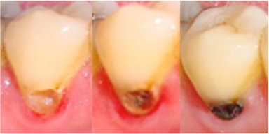
SDF will permanently stain the cavity black.
Healthy tooth structure will not stain.
If accidentally applied to the skin or gums, a brown or white stain may appear that causes no harm, cannot be washed off, and will disappear in 1-3 weeks.
SDF may also stain other materials such as clothing.
Your child may notice an unpleasant taste.
These side effects may not include all of the possible situations reported by the manufacturer. If you notice other effects, please contact our office.
There is no guarantee SDF application will stop the decay. Further treatment may be necessary even after application of SDF.
Alternatives to SDF include but are not limited to the following:
No treatment, which may lead to continued deterioration of the tooth and symptoms may increase in severity.
Depending on the location and extent of the tooth decay, other treatment may include a filling or crown, extraction, or other treatment by a dentist.
I CERTIFY THAT I HAVE READ AND FULLY UNDERSTAND THIS DOCUMENT, AND ALL MY QUESTIONS WERE ANSWERED:

Signature of parent/guardian_________________________________________Date___________________

Signature of witness_________________________________________________Date___________________
Note: Sample form adapted from example provided in the following webinar.

